**Development of Shop Management Game in Unity**

Project Proposal for Level 6 Development Project

There are currently very little shop management games, and training simulators. Games currently availableare very simplistic and hard to navigate. Working as Customer Service Assistants (CSAs) and working as a manager, or supervisor, are very different tasks and sometimes the jump from one to the other is too large. A big problem is the lack of a way to show how managing a shop works and also, how to be good at organizing and running a shop.

Creating a realistic, in-depth simulator/game, to show off the shop environment would be a great addition to a shop’s training system, and can be a great way for people to spend their time, while also developing their skills in important real life ways, such as money management, customer satisfaction, team management etc.

The program created during this project will not be the full game; it will be a stripped down, simpler version to simulate and show off the AI parts and algorithms.

Table of Contents

Introduction**3**

Aims**3**

Objectives**4**

Methodology**4**

Outline Planning**6**

References**7**

# Final Year Project - Full Proposal

## Introduction

This idea came about when I was thinking of ways to spend my free-time, which could also be productive. I then began thinking of creating a game. I work in a Co-Operative convenience store, and I feel like I have worked there for long enough that I know the ins and outs of general store operations and what it is like to be an employee at the lowest level. With this knowledge I felt I could create a very realistic interpretation of my experiences working on a shop floor.

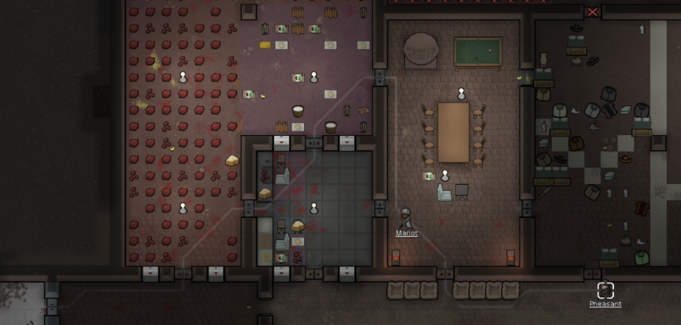 I did some research and found very little shop management games [1] which I thought was surprising, considering the amount of simulation and other types of management games currently online. I realised that there is great potential, and I began thinking about my structure and how I could go about creating the game. I took inspiration from games such as RimWorld [2] and Prison Architect [3] and used these as a basis for how I wanted my game to look and feel.

After watching games similar to the one I wish to create and looking at a handful of ways to begin implementing the different systems I want in my game, such as YouTube tutorials [4], I briefly began trying to code and create the base work for the project. This worked quite well and I have thought about future problems I may run into and how to overcome them. I have decided that the game should use a top-down view since this gives the player the best view to manage the whole shop, and this is what most management games use.

Figure 1: RimWorld pathfinding example

I have scaled back my initial aims for this project to make it more realistic, and my project will be the ‘backbone’ for the rest of the game to build off of. The AI system will be in place, as well as a simple world set up, and other small things to give a good indicator for what can become when the game is carried on past the project deadline.

## Aims

By the end of the project, the aim is to have a program that demonstrates the basic elements of the game and has full A.I. implementation for the employees and the customers. The game should be playable, but with limited, simplistic graphics and UI systems.

The A.I. system should include the following:

* Pathfinding – Most likely version will be the A* algorithm but others will be researched and the best will be chosen.
* Job decisions – The employees will need to decide which job is next on the list, based upon job priorities set by the player. Research will be done on games currently using this system, such as RimWorld [3].
* Shopping Choices – The customers will need to know what products they are after and then look for them. If they can be found by the customer, then the decision needs to be made on whether to actually buy the item based upon the item’s quality and price.

The base game system/UI implementation needs to be completed so that the user can interact with the game and it can be dynamic. The user should be able to play with the program and really get a feel of what the final game will be like. A few examples of systems and parts of the game that will be implemented are as follows:

* World/Tile creation and interaction
* Job designation
* Employee pathfinding and job decisions
* Shopper pathfinding and buying decisions

All of these features will be fully testing using alpha and beta methods.

## Objectives

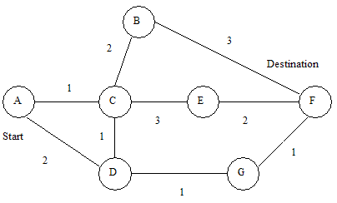 The majority of the work time will be on developing the A.I. for the employees and the customers, and will be the main focus of the project. Some time, but a limited amount, will be used to develop the backbone/outline of the game in order to demonstrate the A.I. in a realistic environment and so that players can get a good sense of the final game once it is developed beyond the project deadline.

There shall be investigations and research on different pathfinding techniques to find out which is best for the situation and to create the most realistic simulation for the game. The A* algorithm would be a good place to start but research will also be conducted on others such as Dijkstra’s.

Figure 2: Dijkstra’s pathfinding algorithm

The backbone/outline of the program will be a tile-based world which can be interacted with, and the player should be able to click on tiles/furniture/characters so that they can receive a realistic simulation of what the full game experience shall be like.

The player will not have a physical character to represent themselves in-game, but they will be able to interact with the world and they must employee characters to work for them who are represented in-game, and will perform jobs. Each character will have a location, a carry weight, a job role, a walk speed, and other similar characteristics. The player will begin with a selection of 5 to 7 randomised characters that all have strengths and weaknesses, they can employ more as the game goes on if their budget allows it. Characters will not just be employees; customers will also have these traits, but these of course won’t be chosen, the shoppers will spawn at the entrance and will be randomly assigned traits.

## Methodology

The main stages will be carried out using the waterfall method. The base/outline of the program will need to the first thing that is developed. Investigations will be carried out to implement world/tile interactivity and then development of the tile features such as furniture will be conducted.

The second part will be the character development, and will be where the characters are made and given traits, and randomness. This whole step is required second due to the world needing to exist first, but the character’s existence is needed before any AI can be developed.

The third stage is the largest and most important part. The AI will be the core of the project and will require the most amount of time and research. Within the AI section, 3 sub-sections are required: Pathfinding, Jobs, and Customer Decisions. The pathfinding will need to be done at the start of the AI system, due to this being essential for every character regardless of whether they are an employee or a customer. The job AI and the customer AI are interchangeable as they are independent from each other. For this reason, the decision will be made to develop the employee job AI second, and then the customer AI third. The employee AI is more important than the customer AI, this is because the employee AI better demonstrates the final version of the game’s AI than the customer AI.

Research will be done through finding documents about already developed management games, and tile-based games, and using their systems and information as a basis for the project’s development. Official documentation on these such games will be used, as well as peer-reviewed documents on game development, tile-based game development and management program development.

The final stage of the project will be testing. There will of course be brief testing for each section throughout the project and on completion of each stage, which will all be documented appropriately, but also a final alpha testing stage at the end program development based upon this proposal, and other initial planning stages created throughout the project. After this, beta testing will be conducted where other people outside the project will be asked to play the game and give feedback on their thoughts and opinions. The game will be sent off to selected persons who are believed to be well educated in real-life shop management, this will give a good opinion on the realism of the program, due to the AI and realism of the program being an important part of the project and development process, as well as other standard persons who will be there to test the game’s ability to be entertaining to play. Upon receiving the feedback and testing results, a final report will be created based upon them and comparisons to the initial predictions and the alpha testing will be conducted.

## Outline Planning

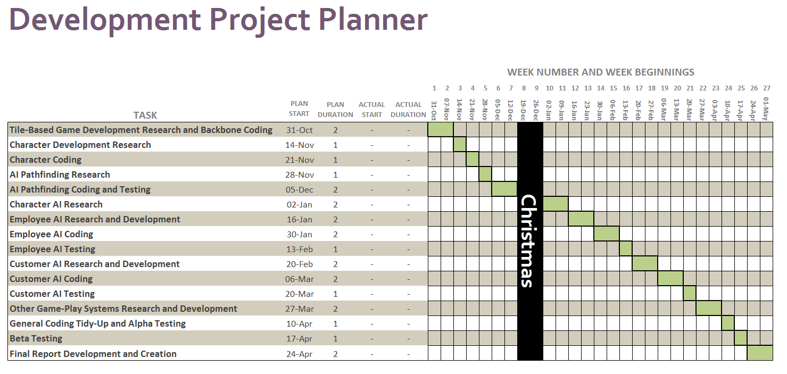Here is the Gantt Chart for this project. It is set up with weekly tasks.

There are currently 2 unused columns, these are for during the project when the beginning of each task can be recorded, as well as the time to completion. This means tasks that have pushed past their allocated time can be identified, or if they were finished with time to spare. With the latter being true, evaluations needed to be conducted upon the reason for the shorter time frame, either the task was not worked on for long enough, or the initial estimation for the length was exaggerated.

# References

[1] CiVue Games, 2015. *Store Manager: Cellular Edition.* [Online]   
Available at: http://store.steampowered.com/app/420910/  
[Accessed 2016].

Figure 2: dotstarmoney, 2015. *Generalized Platformer AI Pathfinding (A guide!).* [Online]   
Available at: http://www.reviewmylife.co.uk/data/2008/0715/dijkstras-graph.gif

[3]Introversion Software, 2015. *Prison Architect.* [Online]   
Available at: http://store.steampowered.com/app/233450/  
[Accessed 2016].

[2]Ludeon Studios, 2016. *RimWorld.* [Online]   
Available at: http://store.steampowered.com/app/294100/  
[Accessed 2016].

Figure 1: Murlaq, 2016. *Rimworld Pathfinding in a Nutshell.* [Online]   
Available at: https://www.reddit.com/r/RimWorld/comments/52a4dm/rimworld_pathfinding_in_a_nutshell/

[4]Quill18Creates, 2015. *Unity Base Building Game Tutorial.* [Online]   
Available at: https://www.youtube.com/playlist?list=PLbghT7MmckI4_VM5q3va043FgAwRim6yX  
[Accessed July 2016].